**Power BI Netflix Content Analysis Dashboard Report**

**1. Identification of Problem Statements**

**Problem Statement 1: Content Performance Optimization**

Netflix needs to understand which content types, genres, and ratings perform best across different markets to optimize their content acquisition and production strategy. Without data-driven insights, Netflix risks investing in underperforming content categories and missing opportunities in high-performing segments.

**Business Impact**: Improved understanding of content performance metrics can lead to more targeted content investments, higher viewer engagement, and better allocation of production resources across genres and formats.

**Problem Statement 2: Geographic Market Intelligence**

Netflix requires comprehensive insights into regional content preferences and engagement patterns to tailor their global expansion strategy. Without region-specific analytics, Netflix may miss opportunities to customize their content library for specific markets.

**Business Impact**: Identifying regional content preferences enables Netflix to develop market-specific acquisition strategies, targeted marketing campaigns, and localized content recommendations, ultimately driving subscriber growth and retention in key markets.

**2. Data Cleaning & Transformation**

**Initial Dataset Structure & Issues**

The initial dataset from Kaggle contained Netflix listings in Excel format with several data quality issues:

* Redundant columns with minimal analytical value
* Inconsistent data types and formatting
* Missing values in key fields
* Non-standardized naming conventions
* Special characters in runtime values
* Mixed content types including irrelevant categories

**Cleaning and Transformation Steps**

1. **Column Elimination**:
   * Removed redundant columns: certificate, popular_rank, summary, language, isAdult, cast, episodes
   * Eliminated video game entries to focus on primary content types
2. **Column Renaming**:
   * Standardized column names for consistency (e.g., start_year → Start Year)
   * Applied proper casing and spacing for readability
3. **Data Type Standardization**:
   * Text: ID, Title, Country, Image URL
   * Whole Number: Votes, Runtime
   * Decimal: Rating (rounded to one decimal place)
4. **Error Handling**:
   * Replaced invalid runtime values containing non-numeric characters with nulls
   * Applied appropriate data type conversions
   * Handled string manipulation for genres and classifications

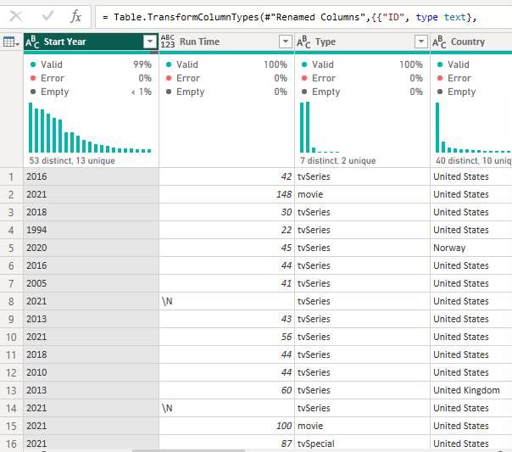

1. **Data Filtering**:
   * Excluded rows with missing ratings or country data
   * Removed non-relevant content types (Video, Video Game, Short)
   * Filtered out entries with null values in critical fields
2. **Data Modeling**

The data model was structured around three core components:

* **Listings Table**: The primary dataset containing all title-level information.
* **Calculations Table**: A dedicated structure for housing all calculated measures and KPIs.
* **Formatting Table**: A static reference table used for conditional formatting and dynamic visual styling of rating groups.

**3. Custom Formula Implementation**

Several DAX (Data Analysis Expressions) formulas were created to enhance the analytical capabilities:

**Primary Genre Extraction**

Genre =

LEFT(

Listings[Genres],

SEARCH(

",",

Listings[Genres],

,

LEN(Listings[Genres]) + 1

) - 1

)

**Purpose**: Extracts the first genre from comma-separated genre lists to facilitate primary genre analysis.

**Content Type Classification**

Listing Type = SWITCH(

TRUE(),

Listings[Type] in {"movie","tvMovie"}, "Movie",

Listings[Type] in {"tvminiseries","tvSeries","tvEpisode","TVSpecial","tvShort"},"Television"

)

**Purpose**: Standardizes content type classification into "Movie" or "Television" categories for clearer analysis.

**Rating Group Bucketing**

Rating Group = SWITCH(TRUE(),

Listings[Rating] >= 0 && Listings[Rating] < 1, 0,

Listings[Rating] >= 1 && Listings[Rating] < 2, 1,

Listings[Rating] >= 2 && Listings[Rating] < 3, 2,

Listings[Rating] >= 3 && Listings[Rating] < 4, 3,

Listings[Rating] >= 4 && Listings[Rating] < 5, 4,

Listings[Rating] >= 5 && Listings[Rating] < 6, 5,

Listings[Rating] >= 6 && Listings[Rating] < 7, 6,

Listings[Rating] >= 7 && Listings[Rating] < 8, 7,

Listings[Rating] >= 8 && Listings[Rating] < 9, 8,

Listings[Rating] >= 9 && Listings[Rating] < 10, 9

)

**Purpose**: Creates rating buckets for easier filtering and visualization of content quality distribution.

**Dynamic Rating Visualization Formatting**

Dynamic Rating Fill =

SWITCH(

TRUE(),

[Avg Rating] >= 0 && [Avg Rating] < 1,"#EBEAEA",

[Avg Rating] >= 1 && [Avg Rating] < 2,"#EAD1D2",

[Avg Rating] >= 2 && [Avg Rating] < 3,"#EAB8BA",

[Avg Rating] >= 3 && [Avg Rating] < 4,"#E99FA3",

[Avg Rating] >= 4 && [Avg Rating] < 5,"#E8868B",

[Avg Rating] >= 5 && [Avg Rating] < 6,"#E86D73",

[Avg Rating] >= 6 && [Avg Rating] < 7,"#E7545B",

[Avg Rating] >= 7 && [Avg Rating] < 8,"#E63B44",

[Avg Rating] >= 8 && [Avg Rating] < 9,"#E6222C",

[Avg Rating] >= 9 && [Avg Rating] < 10,"#E50914"

)

**Purpose**: Enables intuitive color-coding where higher ratings receive deeper shades of Netflix's signature red color.

**Dynamic Map Metric Selector**

z_Parameter: Map Size = {

("Number of Titles", NAMEOF('Calculations'[# Titles]), 0),

("Average Rating per Title", NAMEOF('Calculations'[Avg Rating]), 1),

("Number of Votes", NAMEOF('Calculations'[# Votes]), 2),

("Number of Votes per Title", NAMEOF('Calculations'[# Votes per Title]), 3)

}

**Purpose**: Creates a parameter that enables users to dynamically switch the metric displayed on the geographic map visualization.

**Calculations**

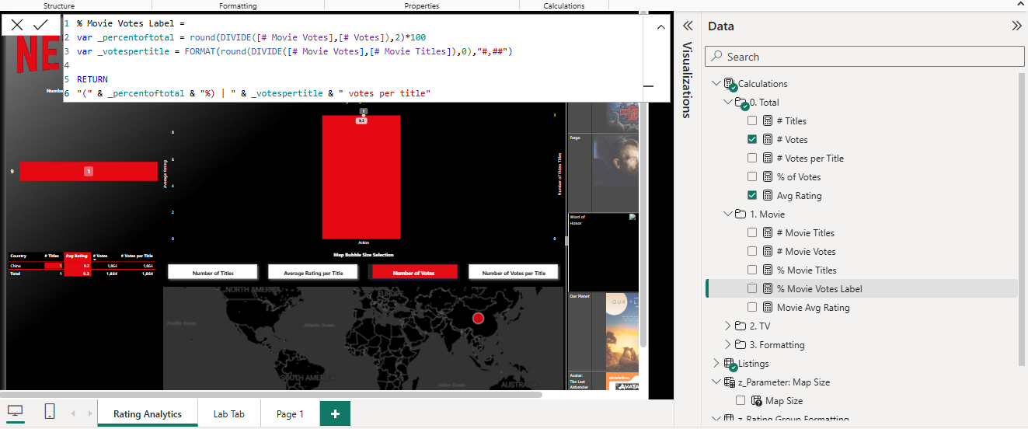

**4. Visualizations and Dashboard Quality**

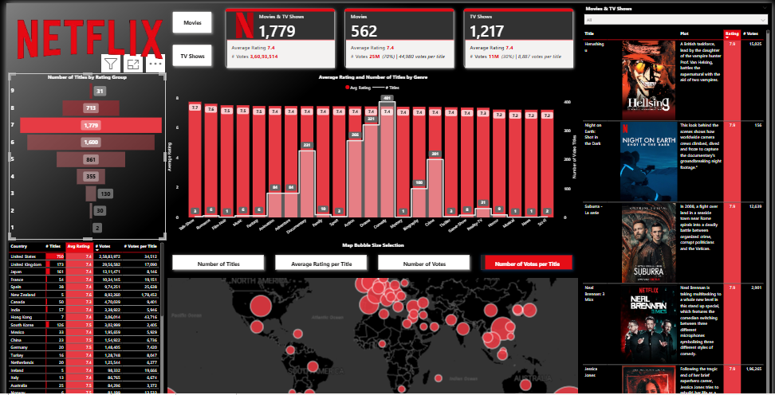

The Netflix content analysis dashboard comprises several interconnected visualizations designed for comprehensive content performance analysis:

**Dashboard Components**

1. **Header and Navigation**
   * Netflix-branded header for instant context recognition
   * Toggle buttons for Movies/TV Shows/All content filtering
   * Reset filter button for quick dashboard reset
2. **KPI Cards**
   * Total content count (1,779 titles)
   * Content breakdown (562 Movies, 1,217 TV Shows)
   * Average ratings visualization with color-coding
   * Total votes and votes per title metrics
3. **Rating Distribution**
   * Horizontal bar chart showing title count by rating group
   * Color-coded with intensity matching rating values
   * Interactive filtering capability
4. **Genre Analysis**
   * Dual bar chart displaying average rating and title count by genre
   * Red bars for average rating metrics
   * Grey bars for title count metrics
   * Genre-based interactive filtering
5. **Geographic Market Intelligence**
   * World map with dynamic bubble visualization
   * Bubble size represents selected metric (titles, ratings, votes)
   * Interactive country selection for filtering
   * Dynamic metric selector for different geographic analyses
6. **Country Performance Table**
   * Detailed country-wise metrics
   * Number of titles per country
   * Average rating by country
   * Percentage of total votes
   * Sortable columns for different analytical perspectives
7. **Content Detail List**
   * Visual card list of titles
   * Content poster images
   * Title, plot summary, rating, and vote count
   * Dynamic filtering based on dashboard interactions

**Visual Design Principles**

* **Color Consistency**: Netflix red theme with varying intensity to represent rating values
* **Interactive Elements**: All visuals connected through cross-filtering
* **Information Hierarchy**: Most important KPIs at top, detailed data below
* **User-Friendly Navigation**: Clear filter options and reset functionality
* **Dynamic Formatting**: Text color changes (black/white) based on background intensity for optimal readability

**5. Insights and Business Interpretation**

**Key Insights**

1. **Content Type Balance**
   * TV Shows outnumber Movies by more than 2:1 (1,217 vs 562)
   * Despite fewer titles, Movies account for a disproportionately higher percentage of user votes
   * Average ratings are similar between Movies (6.7) and TV Shows (6.5)

**Business Implication**: While Netflix has built a strong TV Show library, Movies drive higher user engagement. Netflix should consider increasing movie acquisitions while maintaining TV show quality.

1. **Genre Performance Analysis**
   * Documentary, Drama, and Biography genres maintain the highest average ratings
   * Comedy and Action have high title counts but only moderate ratings
   * Horror shows lower average ratings despite significant presence

**Business Implication**: Netflix should increase investment in documentary and drama content while improving quality standards for comedy and action titles to match their quantity.

1. **Geographic Distribution Patterns**
   * US, UK, and India show highest content representation
   * Smaller European markets show higher average ratings despite fewer titles
   * Emerging markets have lower engagement (votes per title) but growing content libraries

**Business Implication**: Netflix should expand localized content in high-engagement European markets while increasing marketing efforts in emerging regions to drive user interaction.

1. **Rating Distribution**
   * Content with ratings 6-8 represents the majority of the library
   * Very high-rated content (9+) is limited but receives disproportionate engagement
   * Lower-rated content (below 5) has minimal presence

**Business Implication**: Netflix should focus on elevating moderate-performing content (5-7 range) to the high-performing segment (7-9 range) while maintaining quality standards to minimize low-rated additions.

**Recommendations**

1. **Content Acquisition Strategy**
   * Increase investment in documentary and drama genres that consistently outperform in ratings
   * Target acquisition of high-quality movies to balance the content library while maintaining high engagement
   * Develop more original content in the 7-9 rating range, which shows highest user engagement
2. **Regional Strategy Refinement**
   * Develop targeted content strategies for individual high-performing European markets
   * Increase localization efforts in emerging markets to boost engagement metrics
   * Create region-specific content recommendations based on geographic performance data
3. **Marketing and Promotion**
   * Prioritize promotion of high-rated but lower-visibility titles to increase engagement
   * Develop genre-specific marketing campaigns for top-performing categories
   * Create territory-specific promotional strategies based on regional engagement patterns
4. **Dashboard Implementation**
   * Deploy this dashboard as a real-time decision support tool for content acquisition teams
   * Extend the tool to include trend analysis for tracking performance changes over time
   * Integrate viewership data for more comprehensive performance assessment

By implementing these recommendations, Netflix can optimize its content portfolio, enhance regional market penetration, and improve user engagement across its global platform.